Business Plan for SAP ERP Advanced Manufacturing Simulation

Aakriti Gurung
Jasmine Liamsuwan
Mehar Singh Bawa
Mohit Tiwari
Ritika Herwade
College of Business, Colorado State University
CIS 601: Enterprise Computing and Systems Integration
Dr. Jose J Valdes
May 10, 2025

Description of Lessons Learned
During the ERP simulation game, our team at Muesli AG gained valuable insights into managing a manufacturing business, excelling in some areas while identifying opportunities for improvement in others. We effectively leveraged a data-driven approach to pricing and marketing strategies, using Power BI reports to track competitors’ pricing and adjust ours accordingly, which kept us competitive in price-sensitive channels like hypermarkets. Our marketing efforts, guided by real-time insights into competitors’ investments, allowed us to target high-opportunity regions efficiently, maximizing sales without overspending. In planning and production, we excelled by reducing setup times from 8 to 3 hours, boosting capacity utilization above 80% and enabling us to meet demand more consistently. Financially, we managed loans well, repaying them on time to maintain a strong credit rating and strategically withdrawing investments in the final round to enhance company valuation. Data analysis played a key role in tracking raw material price trends, allowing us to seize cost-saving opportunities and positively impact our bottom line. Our team also maintained strong communication through clear role assignments and regular strategy meetings, ensuring alignment across decisions. However, one area where we could have improved was in increasing our production capacity earlier in the game. By expanding capacity sooner, we could have produced and sold more products, potentially securing the top rank in company valuation, which we missed by a small margin. Initially, we offered all 12 products, which stretched our production capacity and caused frequent setup delays; by round 8, we streamlined to six high-demand products, improving efficiency and inventory turnover, though focusing on top sellers earlier could have accelerated profitability. Additionally, integrating data analysis more proactively with production planning could have maximized margins further. Despite strong team collaboration, coordination between production and sales could have been tighter to prevent stockouts of high-demand items. We aim to implement earlier capacity expansion and enhance cross-functional coordination to drive even greater success.
Management
- Mohit Tiwari - Production Lead
Managed production scheduling, monitored bath efficacy, and coordinated inventory levels to align with demand and warehouse constraints.
- Mehar Singh Bawa - Strategy and Data Analytics Lead
Oversaw overall strategic planning, performed in-depth analysis using Power BI, and interpreted financial and operational data to support agile decision-making.
- Aakriti Gurung - Financial Analyst
Regularly reviewed financial statements, tracked key financial indicators, and ensured that our financial decisions aligned with valuation goals and budget constraints.
- Rikita Herwade - Logistics and Stock Transfer Manager
Handled product movement between production and distribution centres, optimized transfer timing, and minimized transportation and warehousing costs.
- Jasmine Liamsuwan - Marketing and Pricing Manager
Led pricing strategy, monitored competitor pricing via Power BI, optimized profitability using sales reports, and executed targeted advertising campaigns based on product performance and regional demand.

Competitive Business Strategies
Our team at Muesli AG adopted a cost leadership strategy during the SAP ERP Advanced Manufacturing Game to establish a strong position in the muesli market. This approach, rooted in Michael Porter’s competitive strategy framework, emphasizes minimizing operational costs to offer competitive prices while ensuring profitability. To achieve this, we implemented several targeted tactics based on insights from the simulation rounds, focusing on production efficiency, cost reduction, and market competitiveness.
We began by optimizing our production process, reducing setup time on our single production line from 8 hours to 3 hours. This adjustment boosted our production capacity utilization above 80%, allowing us to produce more units with less downtime and lower fixed costs per unit. Next, we revised the Bill of Materials (BOM) for our strawberry and blueberry muesli products, cutting the percentage of expensive ingredients like strawberries and blueberries to the minimum allowable 20%. This change reduced variable production costs while adhering to Muesli Manufacturers Association (MMA) standards, directly increasing our profit margins. Additionally, we used Power BI reports to compare our prices with those of other teams, enabling us to maintain competitive pricing that appealed to price-sensitive customers like hypermarkets without compromising profitability.
Market analysis played a key role in our strategy. Through Power BI marketing reports, we tracked competitors’ marketing investments by product and region each round. This allowed us to adjust our own marketing efforts strategically, targeting high-opportunity areas and avoiding overspending. We also analyzed sales data via Power BI to identify the most popular products and regions, gradually streamlining our product line to just seven high-demand items by round 8. This focused reduced production changeovers and aligned output with market demand, further enhancing efficiency.
Financial management was another cornerstone of our approach. We ensured timely loan repayments to maintain a strong credit rating and, in the final round, withdrew investments from setup time and capacity increases to bolster our cash reserves. Since cash on hand is a major component of the company valuation formula in the simulation, these moves significantly increased our valuation, securing a solid financial foundation.
Our key performance indicators (KPIs) included:
- Production Cost per Unit: Targeted 10% reduction through setup time and BOM optimizations.
- Capacity Utilization Rate: Maintained above 80% by focusing on efficient production schedules.
- Inventory Turnover: Increased by aligning production with top-selling products identified in Power BI reports.
These KPIs, tracked via SAP and Power BI, guided our decisions and ensured we stayed on course with our cost leadership goals.
Financial Analysis
Our financial strategy was focused on maximizing company valuation, maintaining strong liquidity, reducing unnecessary costs, and supporting all major decisions with real-time and periodic financial analysis. Insights gained during the ungraded practice rounds shaped a focused and disciplined financial approach that became one of our teams’ key competitive advantages.

Strategic Loan Repayment, Setup Time reduction and Capacity Increment
Early in the simulation, we discovered that repaying the loan significantly improved company valuation. Based on this, we adopted a structured approach of repaying the loan in increments of one million dollars. This amount was chosen because smaller repayments did not trigger credit rating upgrades, and larger repayments risked limiting available cash for operations such as transportation, marketing, and stock transfers.
By consistently reducing the loan over time, we were able to lower interest expenses each round, improve our credit rating, and redirect savings into marketing and other growth-focused activities. This approach set us apart from other teams that delayed loan repayment and continued to incur higher interest costs. We began by optimizing our production process, reducing setup time on our single production line from 8 hours to 3 hours. We invested one million dollars in additional production capacity during the final rounds to support a large-scale output strategy. Although the return was limited due to the short time remaining, it prevented production bottlenecks during a critical period. We also delayed the setup time reduction until the last three rounds. Reducing setup time to three hours supported our plan to produce bulk before Day 10 and halt production thereafter to reduce costs.

Cash Flow Management
We maintained a stable cash revenue between one and 1.5 million dollars throughout the simulation. This level of liquidity gave us the flexibility to manage fixed costs, execute timely stock transfers, invest in marketing, and respond to operational changes without the risk of a cash shortfall like we faced in the ungraded rounds.
Planning
Approach to Independent Requirements Planning and Materials Requirements Planning (MRP):
Our team at Muesli AG developed a robust planning strategy in the SAP ERP Advanced Manufacturing Simulation, leveraging SAP transactions MD61 and MD01 alongside data-driven stock transfer planning to align production with market demand while minimizing costs. We began with a push-based stock transfer approach, distributing inventory evenly across regional warehouses (DCs 10, 12, and 14) at fixed intervals to ensure product availability amid unpredictable demand. This initially led to overstocking in low-demand regions, inflating warehousing costs. By round 5, we transitioned to a hybrid push-pull model, using SAP’s ZMARKET and Power BI sales performance reports to reallocate inventory toward high-demand regions like DC 14 while maintaining safety buffers in slower markets like DC 10. This adjustment balanced supply with demand trends, enhancing stability.
For Independent Requirements Planning, we utilized MD61 to enter planned independent requirements for our top-selling products, such as Strawberry Muesli 1kg and Original Muesli 500g, based on Power BI sales forecasts and ZMARKET demand signals. These requirements were updated regularly to reflect real-time market shifts, ensuring accurate demand projections. Materials Requirements Planning (MRP) was executed via MD01, running total MRP weekly to generate purchase requisitions and production orders, ensuring timely procurement of cost-effective raw materials like strawberries and blueberries, whose price trends we tracked via Power BI’s Raw Material Price Trends chart. This streamlined material availability, avoiding procurement delays noted in early rounds. Our KPIs were monitored via SAP’s ZMB52 and Power BI dashboards, guided our planning, reinforcing our cost leadership strategy by minimizing waste and optimizing resource allocation.
Stock Transfer Planning
Initially our team planned to adopt a push-based approach, we distributed stock evenly across regional warehouses at fixed intervals to mitigate unpredictable demand patterns. While this sometimes led to overstocking in slower markets, it guaranteed consistent product availability and prevented stockouts during demand spikes.
As sales data accumulated, we refined allocations—shifting inventory toward high-demand regions while maintaining safety buffers in others.
This data-driven adjustment:
- Balanced supply with emerging demand trends
- Reduced storage costs by minimizing excess inventory in low-traffic areas
- Created stability despite market fluctuations
The process highlighted how proactive inventory management can bridge uncertainty while providing the analytical foundation to eventually adopt a hybrid push-pull model for greater efficiency.

Production
For the first eight rounds of the game, our group maintained the default production capacity and focused on producing every available product in large quantities. Our initial mindset was to maximize production volume in order to have a presence in all markets and meet a broad range of customer demands. However, as the rounds progressed, we began to see the drawbacks of this approach. Producing a wide variety of products resulted in frequent changeovers on the production line, which consumed valuable setup time and significantly reduced our daily output. This inefficiency created a chain reaction. Since products were not being produced consistently or efficiently, our sales pace slowed, and we struggled to transfer stock to distribution centers in a timely manner. Even when we had inventory available, we were often unable to get it to the right locations fast enough, which limited our revenue growth and affected service levels.
After Round 8, we made the decision to increase our production capacity with the expectation that it would allow us to produce more units or at least maintain current output levels with greater flexibility. Although this expansion gave us more potential throughput, it did not resolve the underlying issue. We were still producing too many products, and this effected production. We realized that spreading our machine time across too many products was still holding us back and making it difficult to respond quickly to market demand.
In the final round, we shifted our approach and adopted a more focused strategy. We carefully reviewed our sales history and identified the six products that consistently performed the best throughout the game. These were the products that not only generated strong demand but also delivered the highest margins. By narrowing our focus to these top-performing products, we reduced complexity and minimized setup losses. At the same time, we capped our daily production to stay within the 25,000-unit capacity. On most days, we produced around 22,000 units, which allowed us to meet demand while avoiding the risk of overproduction and excess inventory. We paid close attention to production volumes, making sure we had enough stock to support sales but not so much that it would create inefficiencies in storage or incur unnecessary warehouse costs.
This change in strategy made a clear difference. By concentrating our efforts on a smaller selection of high-performing products and maintaining a consistent, manageable production volume, we saw improvements across the board. Changeovers became less frequent, throughput increased, and our production process became more stable. Sales moved more smoothly, inventory was better controlled, and our warehousing levels remained efficient. By the end of the final round, we had reached a daily productivity rate of approximately 88 percent. This shift in strategy allowed our group to operate more competitively by emphasizing efficiency, demand responsiveness, and smart product selection.

Marketing Strategy
Our marketing strategy was centred on efficient resource allocation, performance-based targeting, and real-time adjustments to optimize demand while preserving profitability. Instead of relying on static campaigns, we adopted a dynamic and data-informed approach using ZMARKET, ZMB52, Power BI, and sales order profitability reports to guide every marketing and pricing decision.

Advertising Strategy
In the early rounds, we deliberately kept advertising budgets low due to limited availability of finished goods availability. Instead of spreading marketing spending evenly, we allocated funds selectively to products with the highest sales volume and regional demand. To avoid waste, we used ZMB52 to track which SKUs were actively being transferred to each distribution center, ensuring we only promoted products that were available in the targeted region.
Toward the final rounds, especially in the last round, we significantly increased advertising for our top 5-6 products that we were actively producing in bulk. This was done to accelerate sales and minimize leftover inventory. The goal was to convert finished goods into revenue quickly before the simulation ended, supporting both cash flow and company valuation.
Pricing Strategy
Our pricing strategy began with a regional sensitivity model. Based on observed price responsiveness in each distribution center (DC), we increased prices accordingly:
- DC 10: 5% increase (most price-sensitive)
- DC 12: 10% increase
- DC 14: 15% (least price-sensitive)
As the simulation progressed, we shifted to a performance-based dynamic pricing model, adjusting almost daily. We used the Power BI dashboard to compare our product prices against other teams in real-time. If our sales performance in a region was poor, we would adjust the price to be just a little bit below or little bit above the leading team in that region.
We also closely monitored the Sales Orders report to track profit margins by product. If a product was selling but generating low profit, we adjusted the price upward if market conditions allowed. This helped us strike a balance between being competitive and maintaining healthy margins.
In the final round, we reduced prices significantly, sometimes below our target margin, to sell off as much inventory as possible before the simulation ended. While we failed in clearing all finished goods, the strategy minimized leftover stock and improved cash flow in the final valuation.
Ongoing Monitoring and Adjustments
Throughout the game, we actively monitored:
- ZMARKET to check whether our products were still in high demand.
- ZMB52 to track product distribution by region.
- Sales Orders report for margin insights.
- Power BI for competitor pricing and regional sales performance.
By integrating all these tools we avoided unnecessary advertising costs, maximized return on investment, and maintained flexible pricing strategies tailored to product performance and market conditions.

Stock Transfer and Transportation Efficiency
Although stock transfers are operational, they carry significant financial implications. To optimize transportation costs, we scheduled transfers only when a substantial amount of finished goods had accumulated. Transfers were typically made every three to four simulation days, depending on timing within the round. This strategy minimized the number of shipments and helped control logistics expenses while maintaining product availability.

Warehouse Space Cost Control
To avoid unnecessary warehouse costs, we monitored our total inventory levels carefully and ensured we did not exceed the default 250,000-unit warehouse capacity. Exceeding this limit would have triggered additional storage charges, which we actively worked to avoid. Our production and stock transfer decisions were made with this constraint in mind, allowing us to contain overhead costs while keeping inventory available where and when it was needed.
End-of-Game Cash Optimization
In the final round, we reversed non-essential investments such as setup time and capacity wherever possible to maximize our ending cash position. By finishing the game with low debt and high liquidity, we significantly discipline and effective end-game planning.
Visuals
Our team leveraged Power BI to create visualizations that drove our strategic decisions in the ERP simulation. These tools, built from SAP ERP data, provided real-time insights into production, pricing, and market trends, supporting our cost leadership strategy and KPI monitoring. Below are descriptions of key visuals we used:
1. Price Comparison Dashboard
Figure 1 shows a dashboard displaying our product prices alongside competitors’ prices across rounds. By monitoring this data, we adjusted our pricing to stay competitive, ensuring we attracted customers like grocery chains while covering our reduced costs. This visual was critical for maintaining market share in a price-sensitive market.
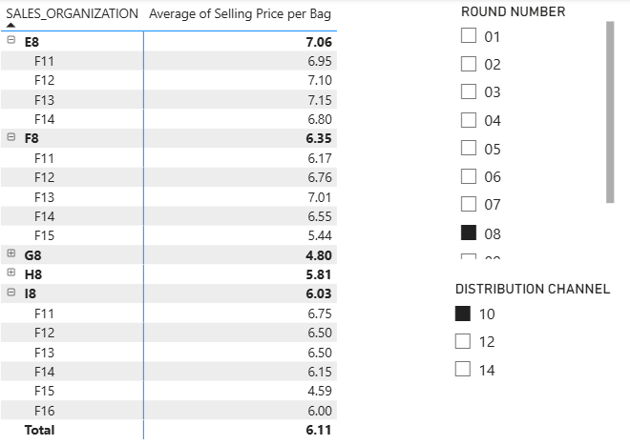
Figure 1: Price Comparison Dashboard
2. Marketing Investment Tracker
A bar chart showing competitors’ marketing investments by product per round. This allowed us to identify where other teams were focusing their efforts and adapt our marketing budget accordingly. For instance, if a competitor heavily marketed Nut Muesli, we shifted focus to underserved areas, optimizing our spend and impact.
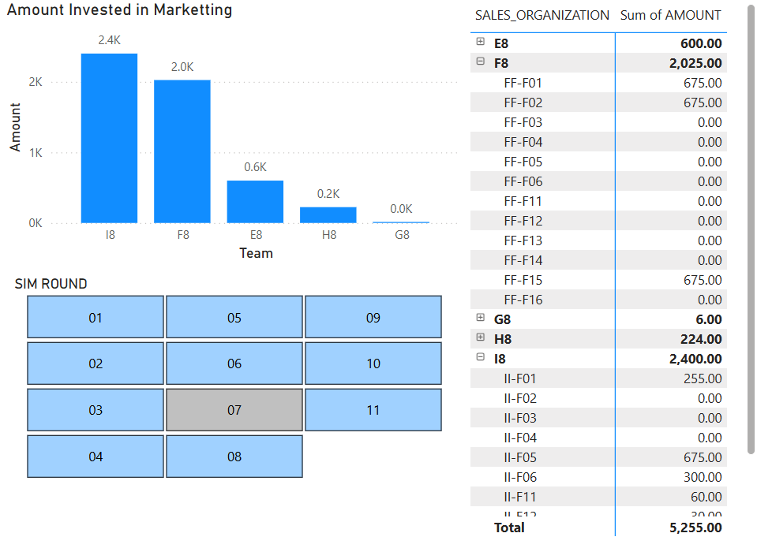
Figure 2: Marketing Investment Tracker
3. Sales Performance Report
This bar graph tracked sales volumes by product and region, highlighting top performers like Strawberry Muesli 1kg. By round 8, it guided us to streamline production to six products, boosting our inventory turnover ratio and reducing excess stock. The report is linked directly to our KPI of increasing turnover, showing how production aligned with demand.

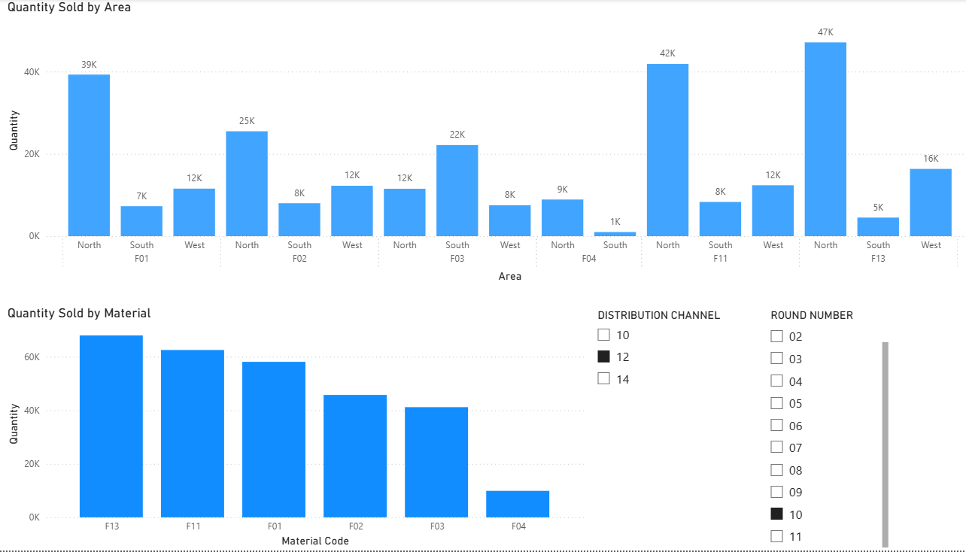
Figure 3: Sales Performance Report
4.Sales Performance by Distribution Channel
This bar chart displayed quantity sold and profit earned per round, segmented by distribution channel (e.g., grocery chains, independent grocers, and hypermarkets). It provided clear insights into channel performance, showing which channels drove the highest sales volumes and profit margins. For example, if grocery chains led in sales volume and hypermarkets in profitability, this visual guided our strategy to optimize production and pricing for each channel. By leveraging this data, we maximized revenue and profitability, reinforcing our cost leadership approach with targeted, channel-specific decisions.
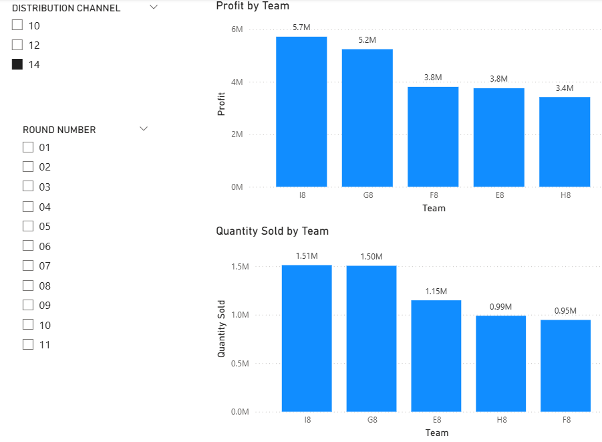
Figure 4: Sales Performance by Distribution Channel
5. Raw Material Price Trends
This line chart tracked raw material prices over time, focusing on key ingredients like strawberries and blueberries, which showed decreasing prices during certain periods. By analysing these trends, we strategically increased the production of strawberry and blueberry muesli when costs dropped, lowering our variable expenses and improving profit margins. This proactive adjustment to procurement and production timing allowed us to capitalize on market opportunities, ensuring competitive pricing while maintaining profitability—a cornerstone of our data-driven cost leadership strategy.
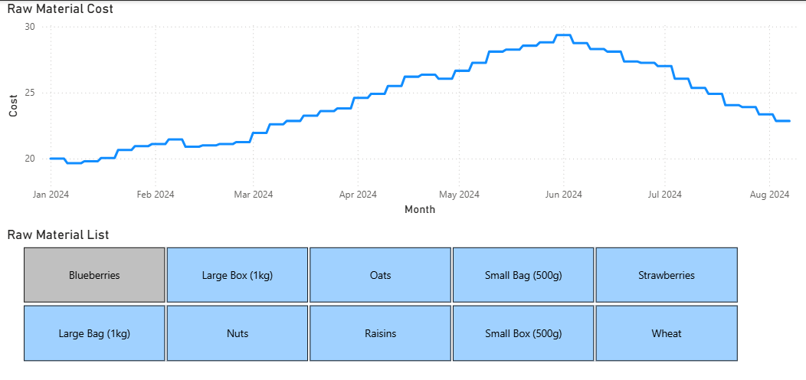

Figure 5: Raw Material Price Trends

Results and Reflection
Throughout the 11-round ERPSIM simulation, our team (Team F) consistently ranked at the top, finishing in first place for 7 out of 11 rounds based on company valuation. We maintained a strong lead in most of the game through coordinated efforts, real-time analysis, and strategic decision-making across all departments.
Our closest competitor, Team I, remained highly competitive throughout the simulation and ultimately overtook us in the final round, placing our team in second overall. While this outcome reflected a very close race, we are proud of our team’s strong showing and ability to hold the lead for the majority of the game.
Our success was largely driven by a well-structured loan repayment strategy, tight cash flow management, careful control over warehouse and transfer costs, and dynamic pricing supported by Power BI and SAP reports. We prioritized improving company valuation rather than short-term profit, focusing on reducing liabilities and optimizing liquidity.
However, the final round highlighted areas for improvement. Although we had produced a large quantity of finished goods, our stock transfer and production planning fell short, resulting in unsold inventory that could have boosted our ending valuation. Additionally, we recognized that we could have lowered prices earlier and increased marketing spend on key products to accelerate final sales. These adjustments may have allowed us to maintain our lead through the last round.
Despite finishing second, we consider our overall performance a success. This simulation taught us the importance of cross-functional alignment, strategic timing, and using real-time data to drive decisions. Most importantly. It reinforced that every round matters and that end-game execution is just as critical as early strategy in maximizing company performance.

